Meeting Notes

***Meeting Agenda*** –Meeting with Chris to complete building the circuit and create the final design

***Meeting Attendance:***

Balaji Radhakrishnan (u7322353)

Bhargav Ashok (u7172176)

The other team member’s presence was not necessary since the physical circuit is being developed by the electrical team.

|  |  |
| --- | --- |
| ***Meeting Notes:*** | ***Meeting Duration ~ 120 minutes*** |

The agenda for the meeting was to complete majority of the the electrical work associated with circuit. Balaji R began by completing the connections for the resistor, capacitor. Additionally, we added a potentiometer to control the current and a switch to complete or break the circuit. Bhargav A started finalising the circuit which would be used as a reference for further use or development. Below are two images, Image 1 is the how the final circuit looks post connections and Image 2 is of the circuit.

***Meeting Outcomes:***

1. Completed circuit with remaining connections to the resistor, capacitor and inductor
2. Completed final circuit diagram

***Current Deliverables:***

Test the device to ensure the current is being passed safely through the circuit and if the circuit can be used to pass current through solar panels

***Appendix:***

Below is an image of the circuit developed during the meeting

Image 1

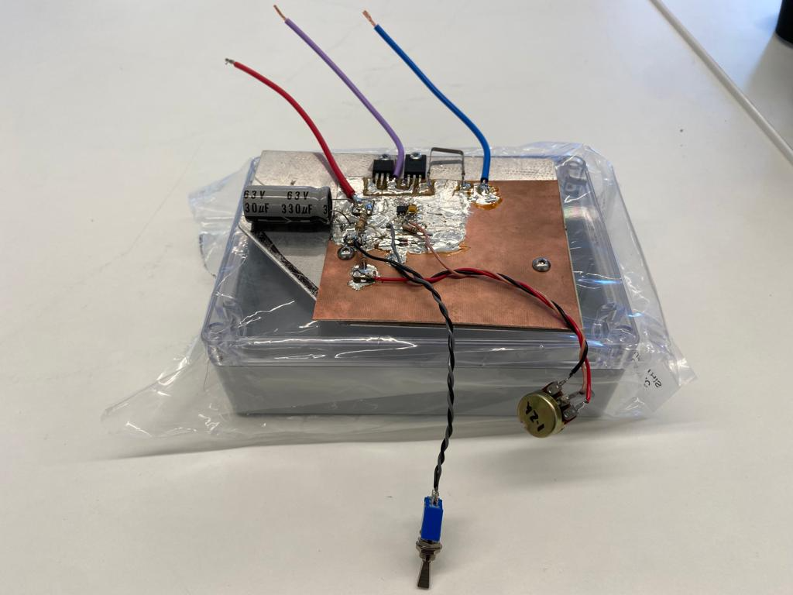

Image 2

